Pet details

Workshop #04

Flutter Developer Bootcamp

# **Purpose**

This workshop demonstrates how to create a pet details screen

# **Problem**

Create a Flutter application that displays details of a pet, including an image of the pet, and implement a feature to allow users to repost the pet's details by tapping on an icon positioned on the top-right corner of the image.

**Here's your challenge:**

Design a Pet Details screen with the following components:

* + Display the image of the pet.
  + Show relevant details of the pet (e.g., name, breed, age, etc.).
  + Implement a Repost icon on the top-right corner of the image.

# **How to Solve**

1. Checkout the workshop from Git Repo:

git clone -b <user-branch> <repo-URL>

2. Open the root folder inside VS Code

3. To build the app click the run option in the main method { }

4. Display a pet image and place a repost icon on the image at the top-right corner.

**You Will Achieve**

In this Flutter workshop, you will learn to create a pet details screen. You will use Flutter widgets to design the interface, organise elements with Columns and Rows, and style them. Additionally, you will handle images and user interaction with buttons. The workshop covers basic layout techniques and widget usage, making it a great starting point for Flutter beginners.

# **Screenshots**

## **Before implementation (without Image & Report icon)**

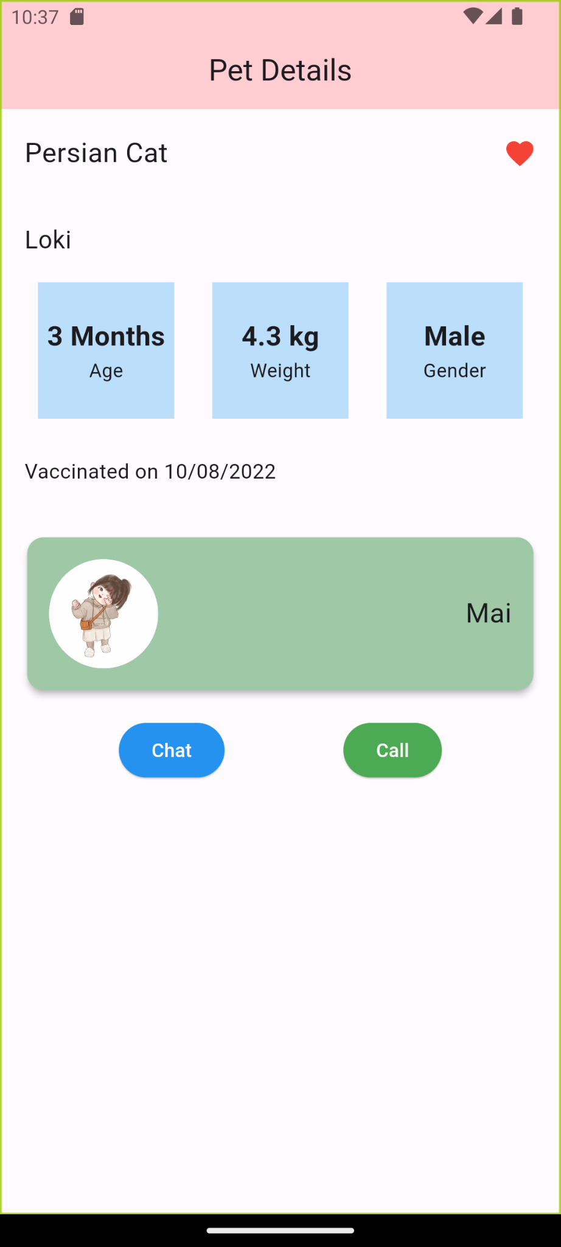

## **After implementation (With Image & Report icon)**

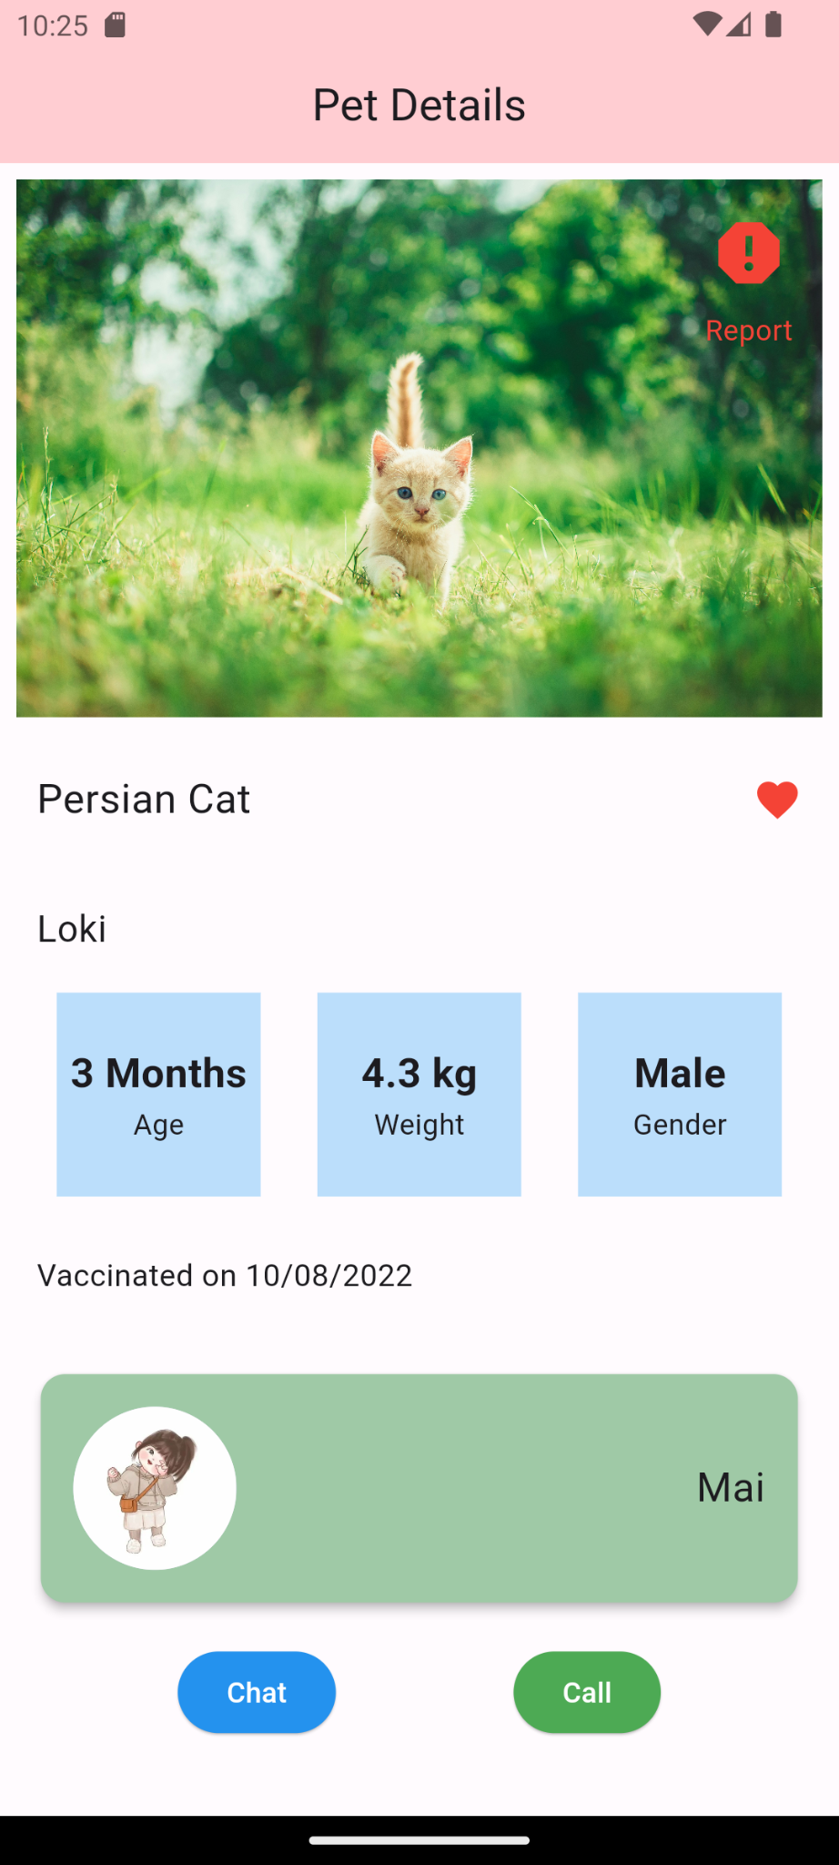

# **How to submit your workshop**

Push your project back to the same git branch using command:

<command name>

# **Happy Coding!**